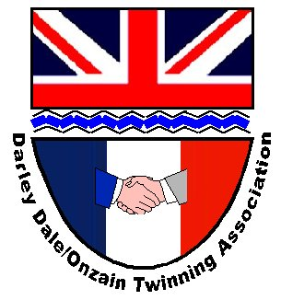

DARLEY DALE AND DISTRICT
TWINNING ASSOCIATION
Kevin Senior 48 Painters Way
Two Dales
Matlock
DE4 2 SB 01629 733053/07768 922003
E-mail: kevinfsenior@hotmail.com

Twinning Weekend 16/17 June 2018

Travel
Darley Dale Twinning Association has organised a 49 seater coach for the journey, leaving Darley Dale on Friday 15 June at approx. 5.00am, to arrive in Onzain Friday evening approx. 6.00p.m (local time). the return departure will be Monday 18 June 7.00am to be back in Darley Dale on Monday evening approx. 10.00pm. At the moment, the cost per seat is £86.00 (if full coach) or £140.00 (if 30 passengers). Obviously, the price will vary depending on final number of passengers and will be even less, when we know exactly the amount of grant aid we receive to subsidise the cost. For the time being, all coach passengers must send a £25.00 non-returnable deposit - cheques should be made payable to "Darley Dale & District Twinning Association" and sent to me by 10 February. Final payment can be made once full cost has been determined.

You may want to make your own travel arrangements; flying, driving, or train. If this is the case, please let me have that information, on the form provided. Please remember that you need to arrive in Onzain at the same time as the coach. Some hosts may be at work during the day and not available to greet you if you arrive early. If, for any reason, you are going to arrive later than this please let your hosts know as soon as you can.

It is likely that there will be an official reception, when you will meet your hosts and be taken to their home for an evening meal.

It would be very useful if everybody, who is intending to go to Onzain, would complete and return the accompanying form(s) with the information required. For those who are travelling for the first time, this information is required in order to match you with an appropriate host family. Any youngsters, under 18 years and not travelling with their parents, must complete the "loco-parentis" form enclosed - this is to allow any legal or medical procedures to go ahead, if necessary.

You will need to have your own travel insurance along with your passport and EHIC card. (European Health card from the post office or on line)

Accommodation
You will stay with a French family for the weekend, many of whom speak good English. They will look after you well, providing meals, transport and hospitality. It is our normal courteous practice to take a gift by way of thanks. Details of hosts will be forwarded at a later date and will enable you to make advance contact, should you wish to do so.

Itinerary
This is not known at the moment but, based on previous experiences, it is likely to be a very busy two days.

If you need any more information, please contact Kevin - details as above.

